– FINAL PROJECT –

REST API: Online Debit/Credit Card

# Membuat Project Baru Melalui Visual Studio

1. Create a New Project > Next

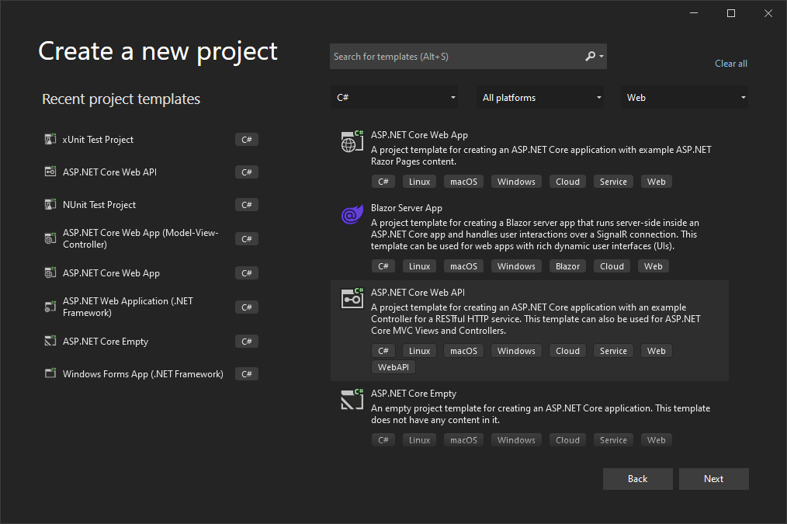

1. Mengisi kolom Project Name menjadi ‘PaymentAPI’ > Pada Kolom Lokasi arahkan pada folder FinalProject > Next

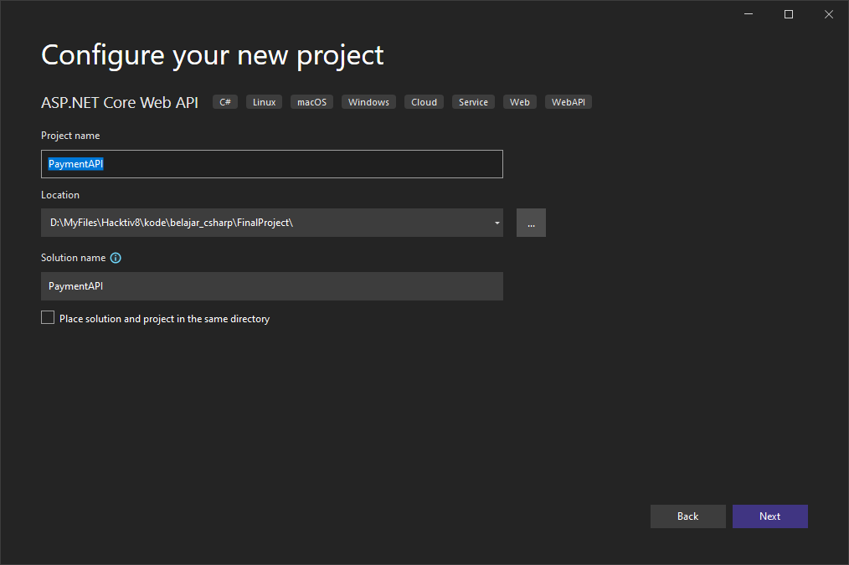

1. Ikuti Konfigurasi > Create

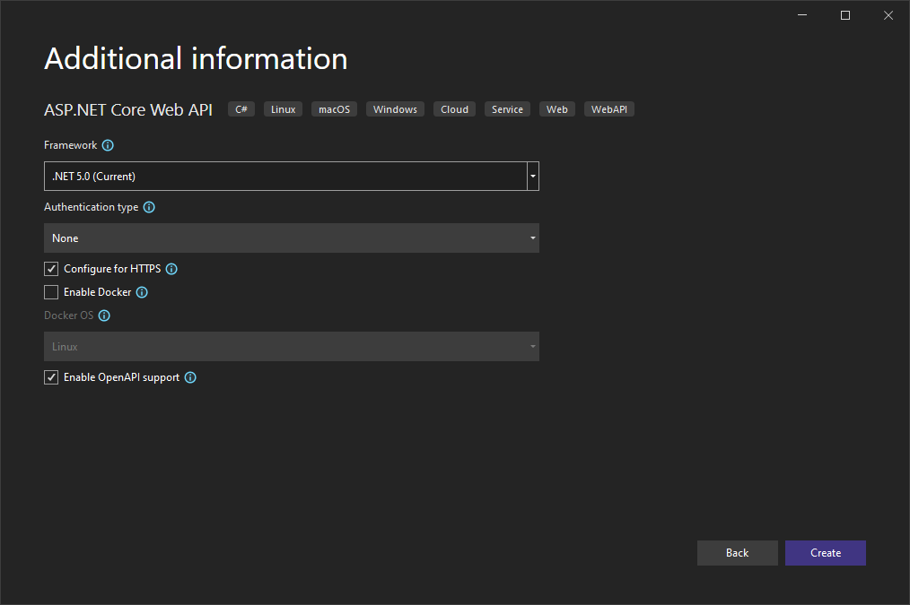

# Membuat Database di Hosting

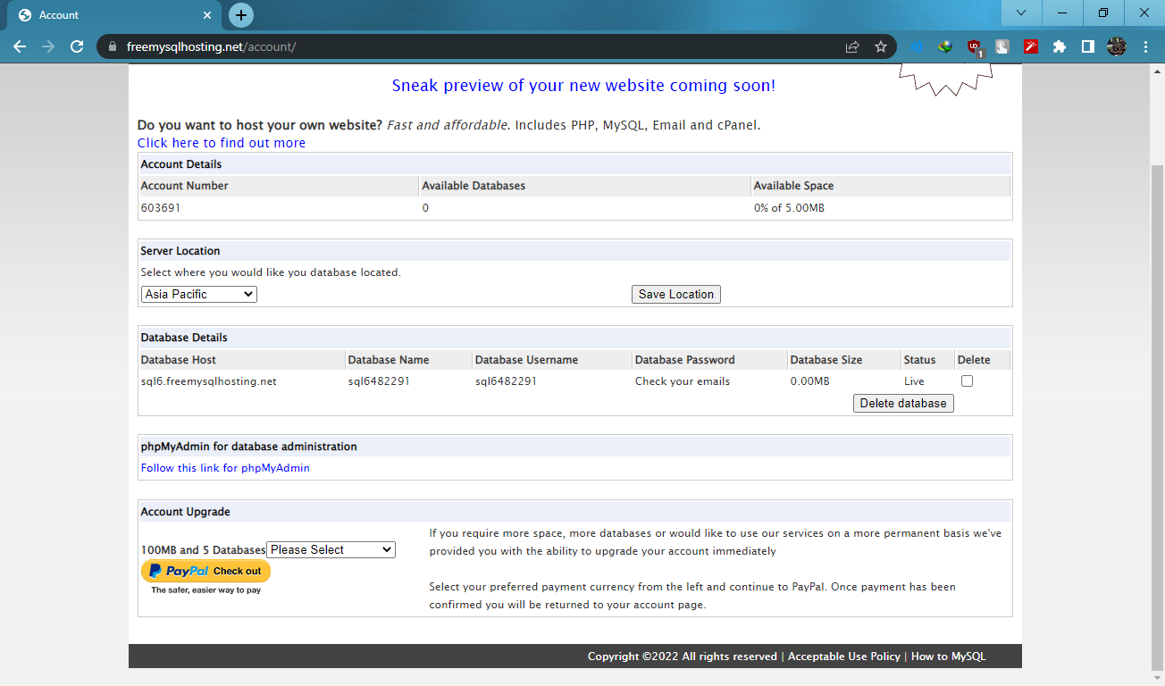

**Server:** [sql6.freemysqlhosting.net](http://sql6.freemysqlhosting.net/)  
**Name:** sql6482291  
**Username:** sql6482291  
**Password:** *********  
**Port number:** 3306

**REMOTE DATABASE VIA NAVICAT**

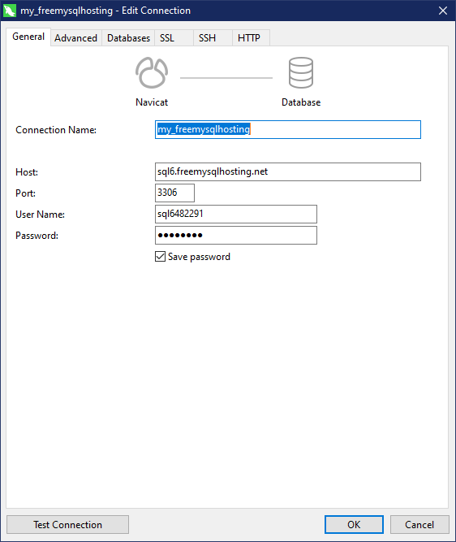

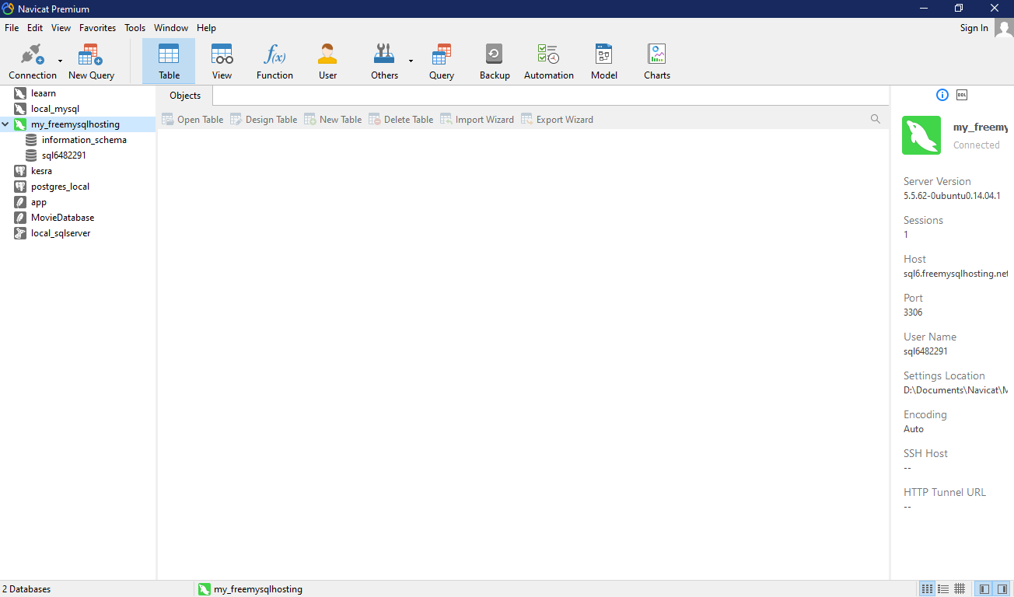

# Install Package via Nugget Package Manager Visual Studio

List package yang perlu diinstall:

|  |  |  |
| --- | --- | --- |
| Nama Paket | Versi | Deskripsi |
| Microsoft.AspNetCore.Authentication.JwtBearer | 5.0.15 |  |
| Microsoft.AspNetCore.Identity.EntityFrameworkCore | 5.0.15 |  |
| Microsoft.AspNetCore.Identity.UI | 5.0.15 |  |
| Microsoft.EntityFrameworkCore | 5.0.15 |  |
| Microsoft.EntityFrameworkCore.Design | 5.0.15 |  |
| Microsoft.EntityFrameworkCore.Tools | 5.0.15 |  |
| MySql.Data | 8.0.28 |  |
| MySql.EntityFrameworkCore | 5.0.10 |  |
| NuGet.CommandLine.XPlat | 6.1.0 |  |
| Swashbuckle.AspNetCore | 5.6.3 | for auto generating your swagger definition |
| System.IdentityModel.Tokens.Jwt | 6.16.0 |  |

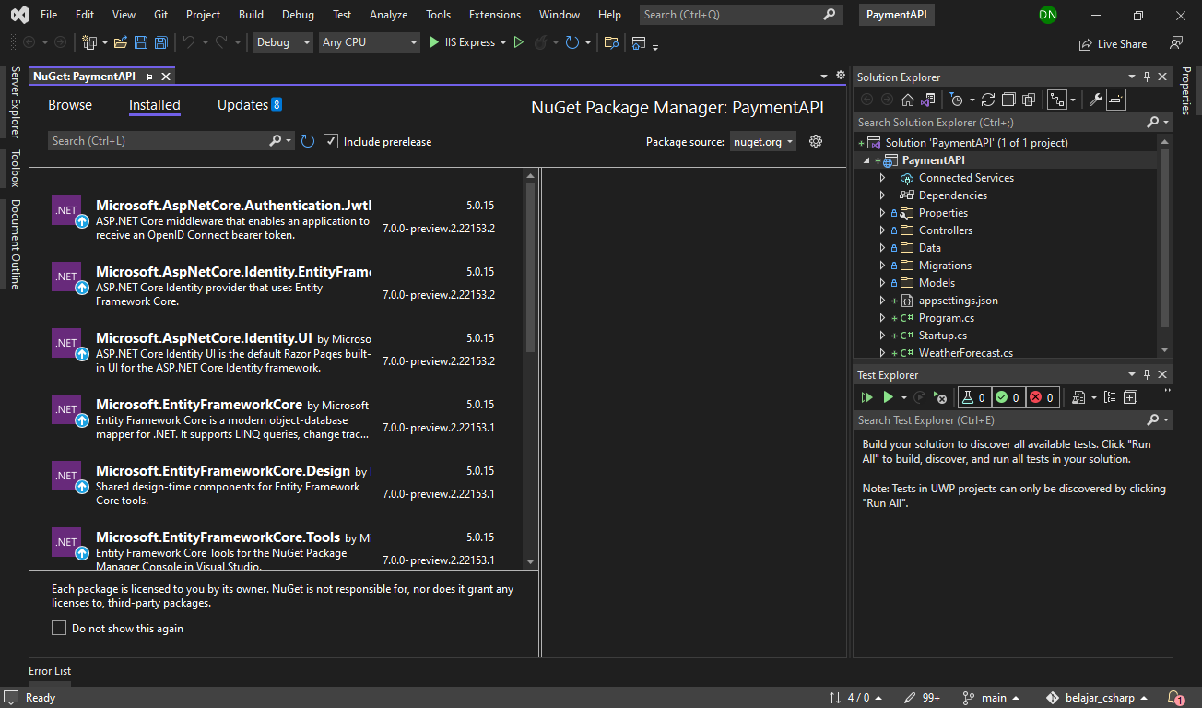

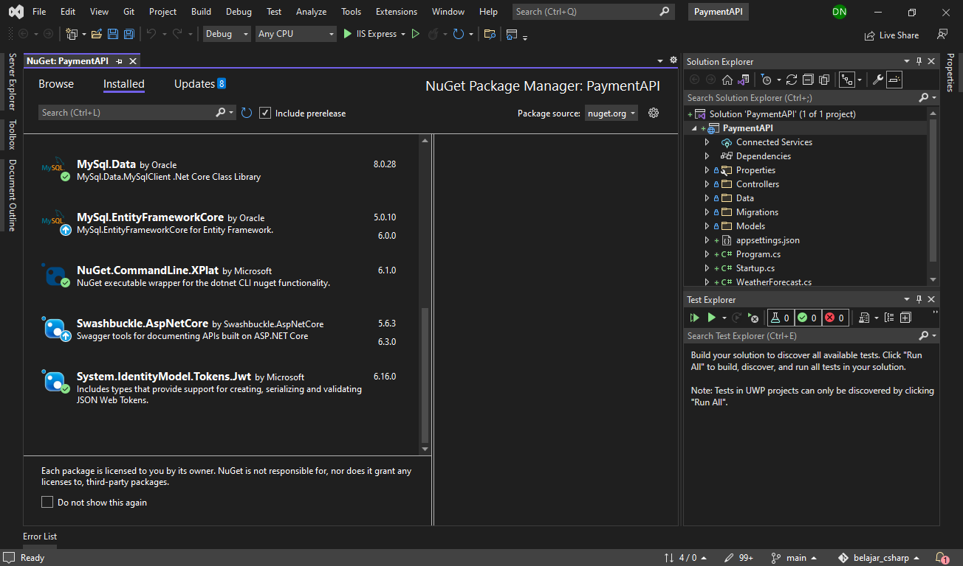

# Pembuatan Kelas/Object Payment dan ApiDbContext

1. Membuat Folder Untuk Models
2. Pada ‘PaymentAPI/Models’ menambahkan file PaymentItem.cs sebagai kelas/object data Payment.

------------------------------------------------------------------------------------------

‘PaymentAPI/Models/PaymentItem.cs’

------------------------------------------------------------------------------------------

using System;

using System.ComponentModel.DataAnnotations;

namespace PaymentAPI.Models

{

    public class PaymentItem{

        [Key]

        public int paymentDetailId {get; set;}

        public string cardOwnerName {get; set;}

        public DateTime expirationDate {get; set;}

        public string securityCode {get; set;}

    }

}

------------------------------------------------------------------------------------------

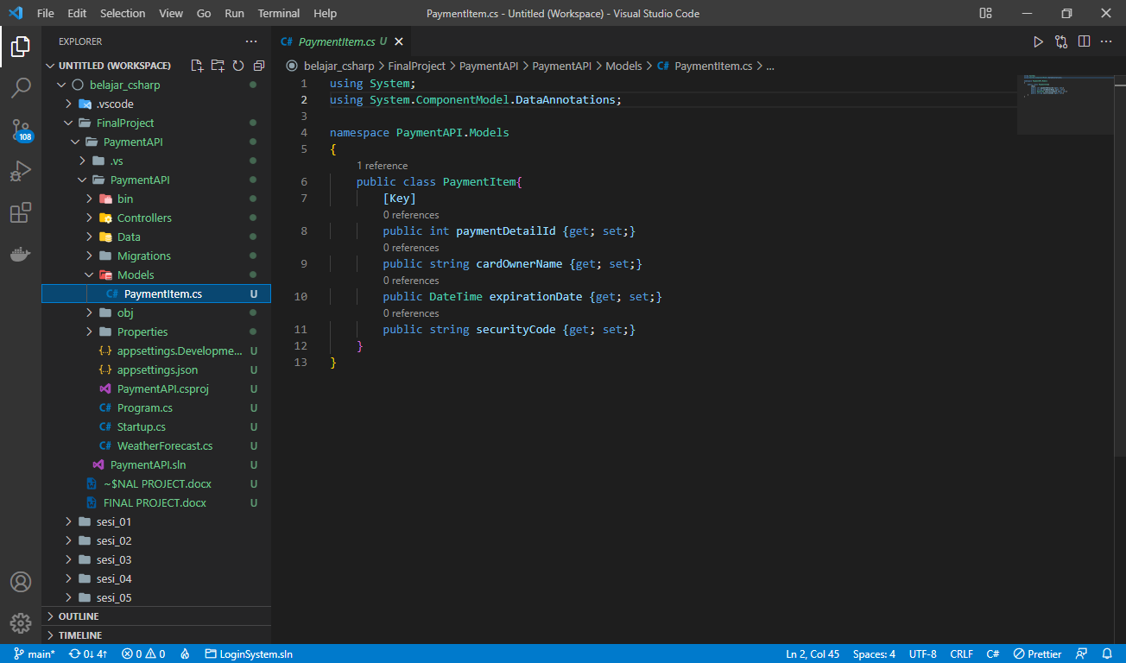

1. Membuat Folder Data
2. Pada ‘PaymentAPI/Data’ menambahkan file ApiDbContext sebagai tempat pendefinisian Tabel PaymentDetails.

------------------------------------------------------------------------------------------

‘PaymentAPI/Data/ApiDbContext.cs’

------------------------------------------------------------------------------------------

using Microsoft.EntityFrameworkCore;

using PaymentAPI.Models;

using Microsoft.AspNetCore.Identity.EntityFrameworkCore;

using Microsoft.AspNetCore.Identity;

namespace PaymentAPI.Data

{

    public class ApiDbContext : IdentityDbContext

    {

        public virtual DbSet<PaymentItem> PaymentDetails {get; set;}

        public ApiDbContext(DbContextOptions<ApiDbContext> options):base(options)

        {

        }

    }

}

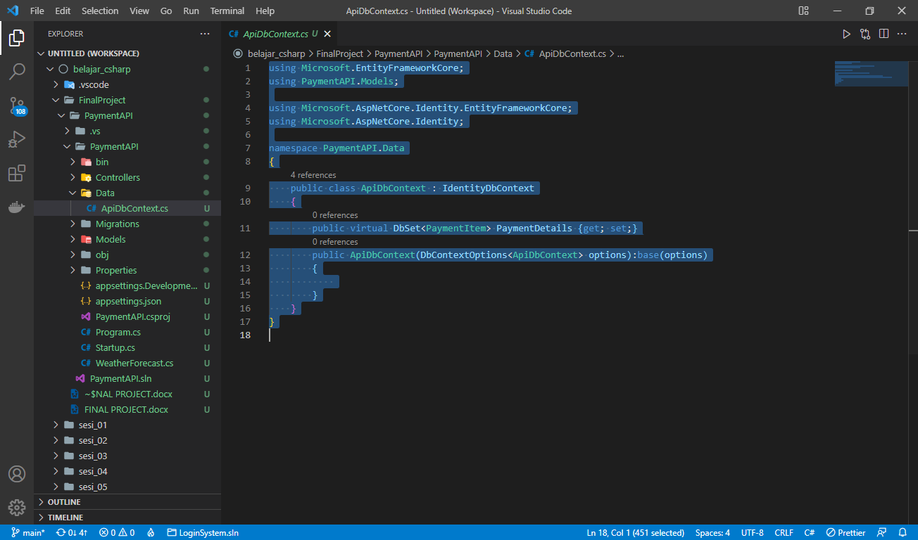

# Pembuatan Controller CRUD Payment

1. Pada ‘PaymentAPI/Controllers’, menambahkan file ‘PaymentDetailController.cs’

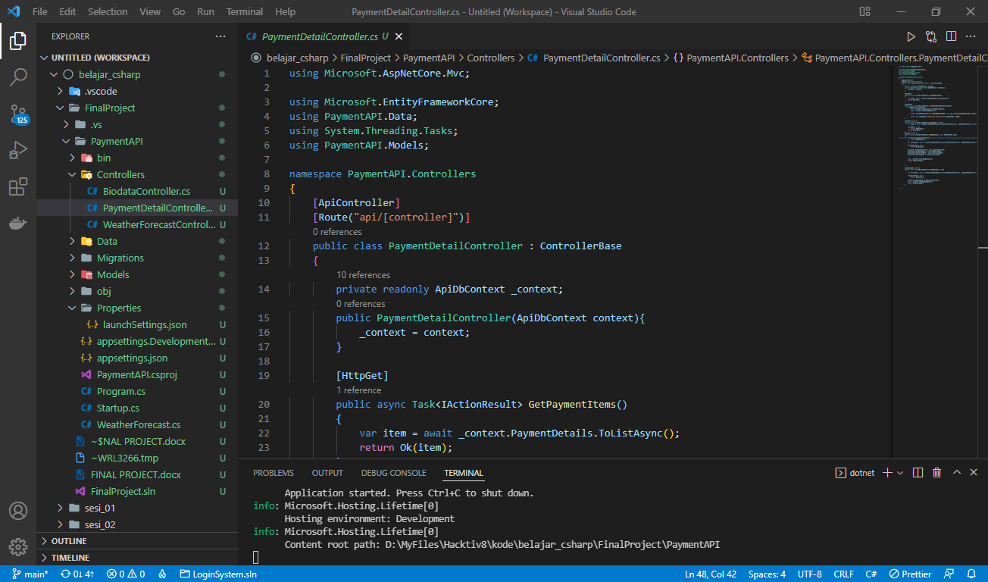

# Penambahan JWT Token dan RefreshToken

1. Pada ‘PaymentAPI’, menambahkan Folder ‘Configuration’
2. Pada ‘PaymentAPI/Configuration’ menambahkan file

* ‘PaymentAPI/Configuration/AuthResult.cs’

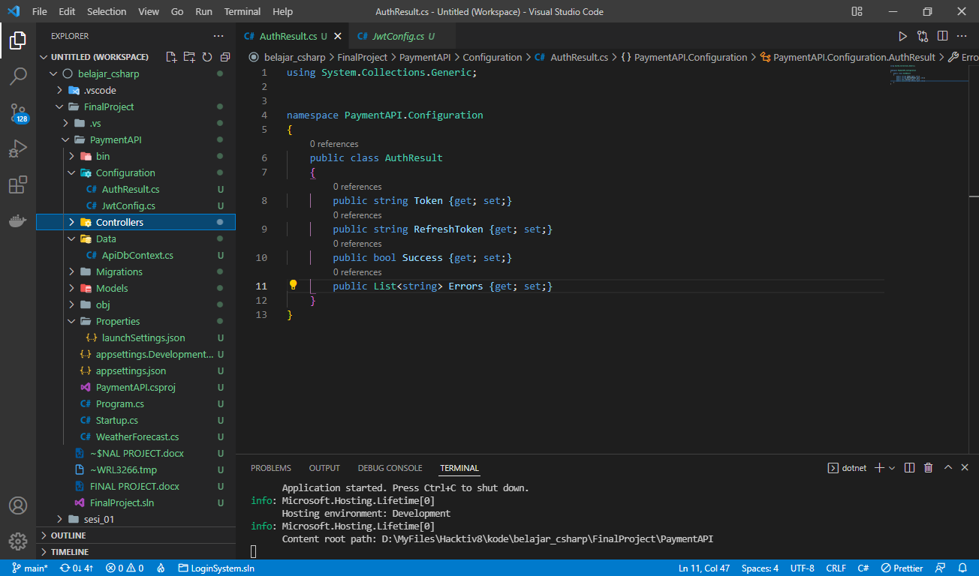

* ‘PaymernAPI/Configuration/JwtConfig.cs’

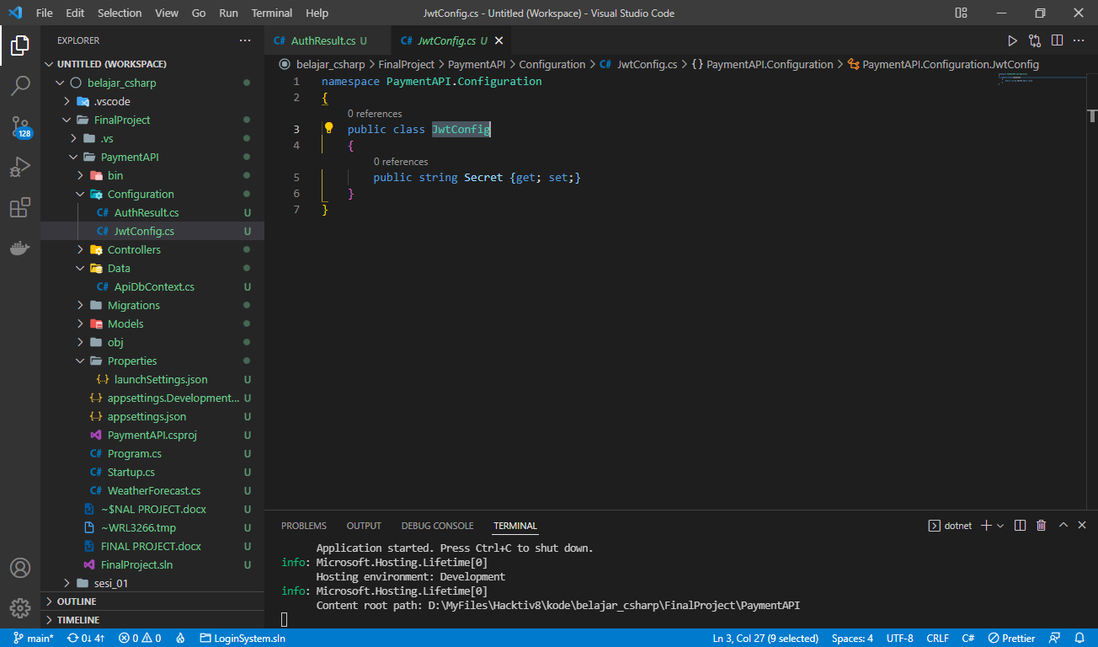

1. Menambahkan JwtConfig.Secrets pada ‘PaymentAPI/appsetting.json’

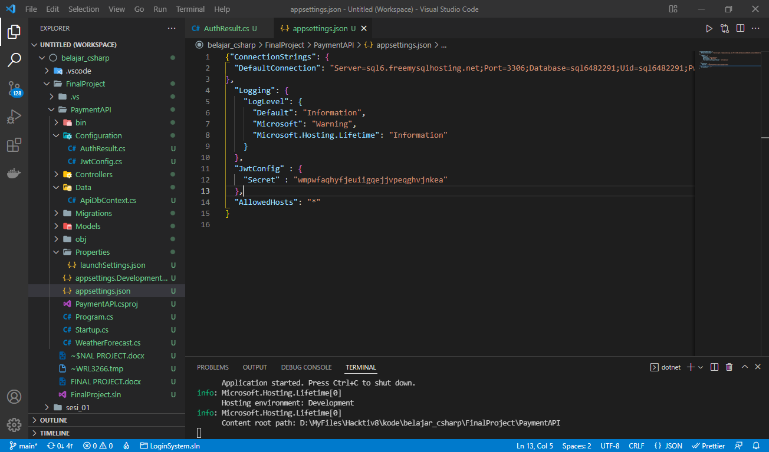

1. Menambahkan DbSet untuk Tabel RefreshToken pada ‘PaymentAPI/Data/ApiDbContext.cs’

public virtual DbSet<RefreshToken> RefreshTokens {get;set;}

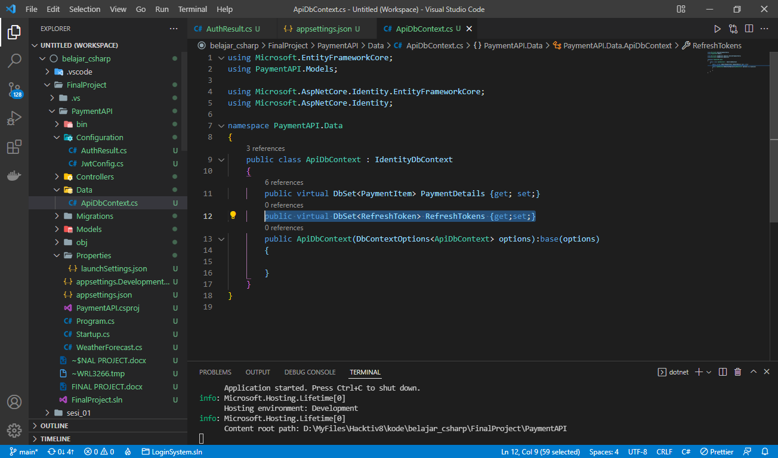

1. Pada ‘PaymentAPI/Models’ menambahkan DTO request dan response pada Models

* ‘PaymentAPI/Models/DTOs/Requests/UserRegister.cs’

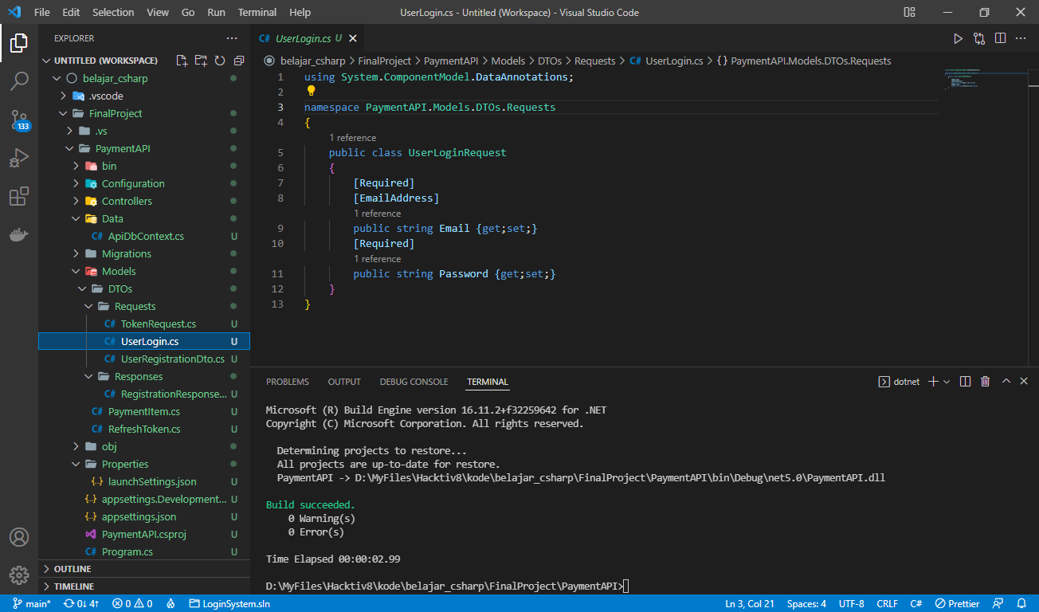

* ‘PaymentAPI/Models/DTOs/Requests/UserLogin.cs’

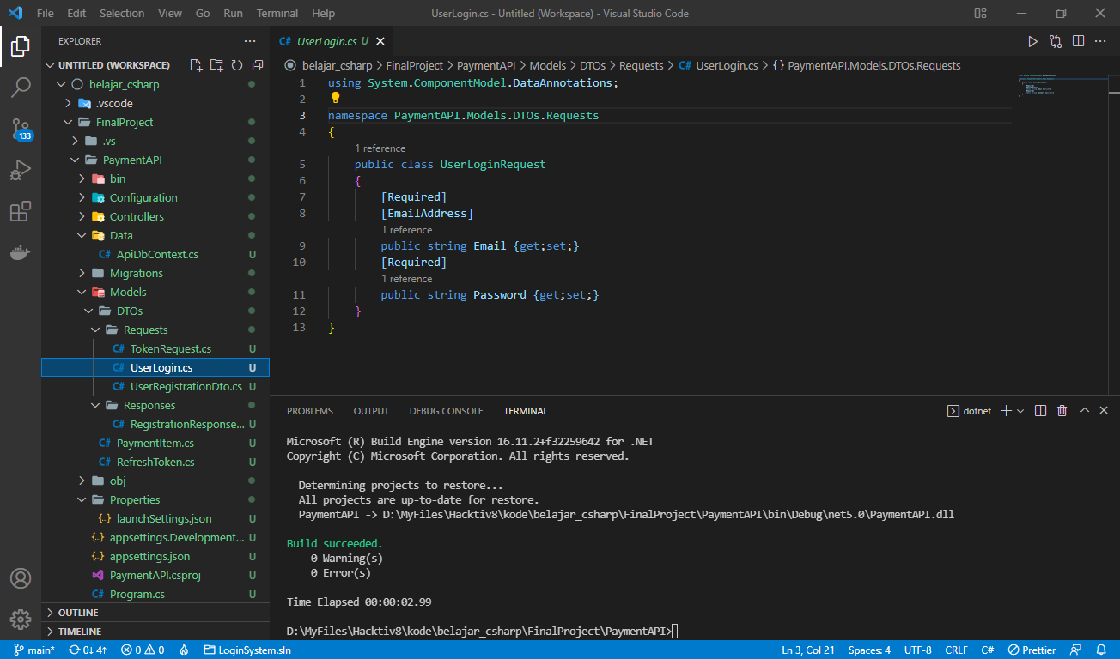

* ‘PaymentAPI/Models/DTOs/Requests/TokenRequest.cs’

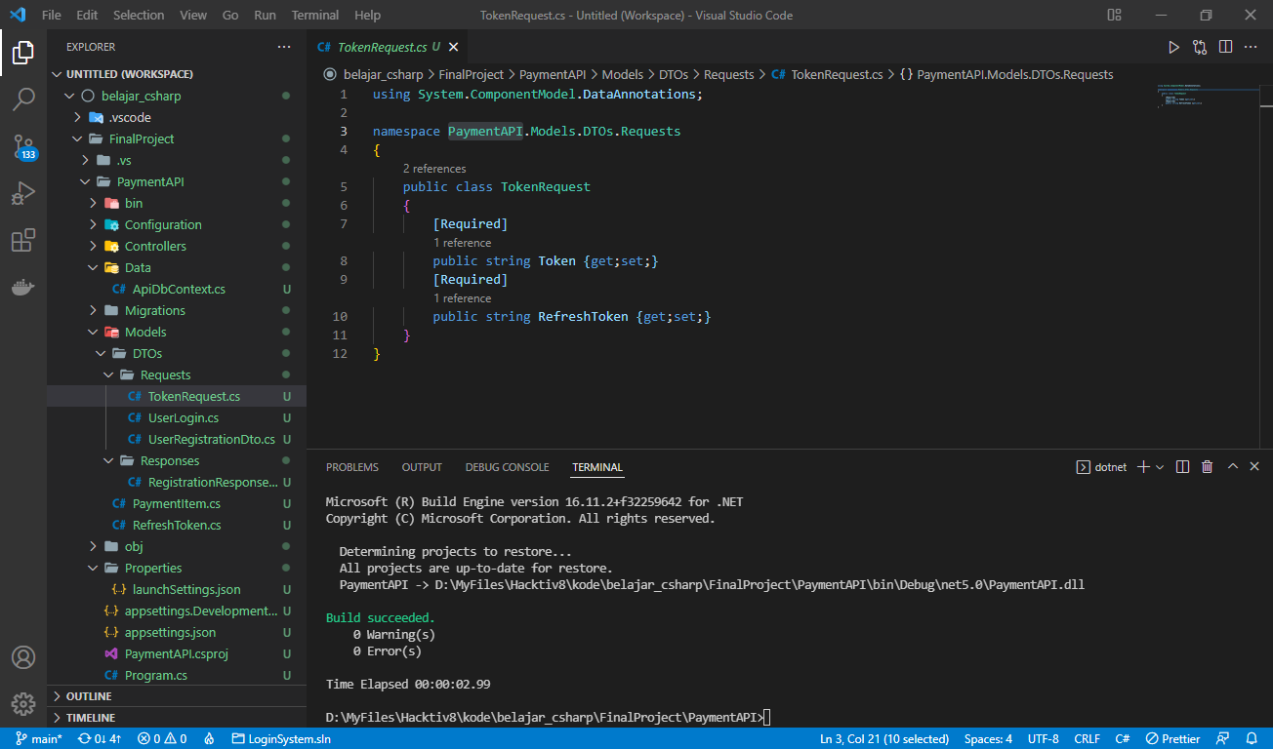

* ‘PaymentAPI/Models/DTOs/Responses/RegistrationResponse.cs’

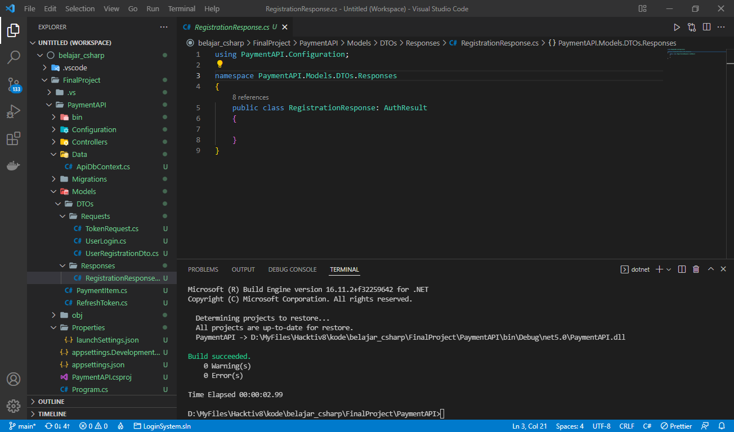

1. Penambahan Controller untuk AuthManagement

‘PaymentAPI/Controllers\/AuthManagement.cs’

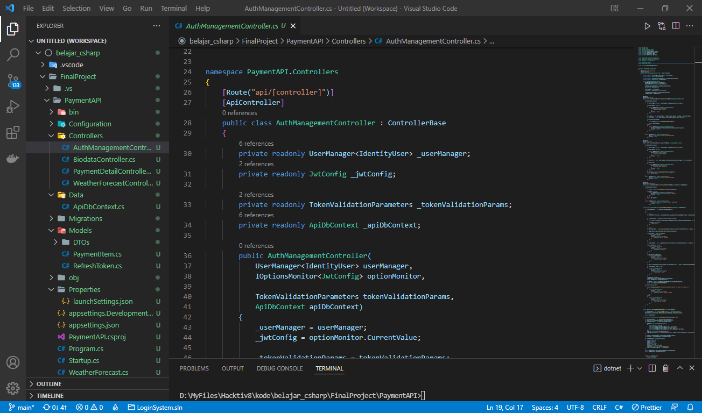

1. Pada ‘PaymentAPI/Startup.cs’, di dalam method ‘ConfigureServices’ setelah ‘services.AddDbContext’ menambahkan baris kode dibawah ini:

services.Configure<JwtConfig>(Configuration.GetSection("JwtConfig"));

            var key = Encoding.ASCII.GetBytes(Configuration["JwtConfig:Secret"]);

            var TokenValidationParameters = new TokenValidationParameters {

                    ValidateIssuerSigningKey = true,

                    IssuerSigningKey = new SymmetricSecurityKey(key),

                    ValidateIssuer = false,

                    ValidateAudience = false,

                    ValidateLifetime = true,

                    RequireExpirationTime = false,

                    ClockSkew = TimeSpan.Zero

                    };

            services.AddSingleton(TokenValidationParameters);

            services.AddAuthentication(options => {

                options.DefaultAuthenticateScheme = JwtBearerDefaults.AuthenticationScheme;

                options.DefaultScheme = JwtBearerDefaults.AuthenticationScheme;

                options.DefaultChallengeScheme = JwtBearerDefaults.AuthenticationScheme;

            } ).AddJwtBearer(jwt=>{

                jwt.SaveToken = true;

                jwt.TokenValidationParameters = TokenValidationParameters;

            });

            // using aspNetCoreUI

            services.AddDefaultIdentity<IdentityUser>(options => options.SignIn.RequireConfirmedAccount = true).AddEntityFrameworkStores<ApiDbContext>();

# Migrasi dan Update Database

1. Pada ‘PaymentAPI/appsettings.json’, menambahkan ‘ConnectionStrings.DefaultConnection’

"ConnectionStrings": {

  "DefaultConnection": "Server=sql6.freemysqlhosting.net;Port=3306;Database=sql6482291;Uid=sql6482291;Pwd=;"

}

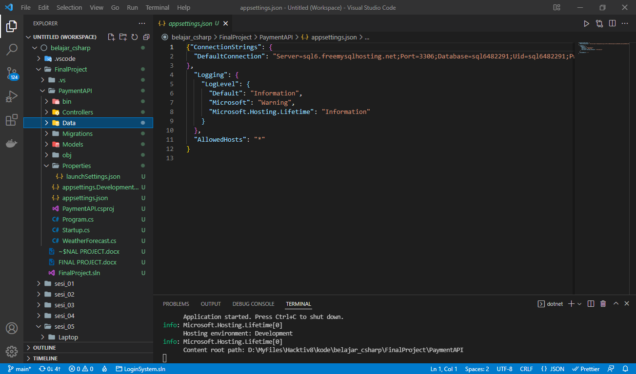

1. Pada ‘PaymentAPI/Startup.cs’ menambahkan ‘services.AddDbContext’

services.AddDbContext<ApiDbContext>(options =>

                options.UseMySQL(Configuration.GetConnectionString("DefaultConnection")));

1. Pada ‘PaymentAPI/Controllers/PaymenDetailsController.cs’, bagian setelah [ApiController] tambahakn baris dibawah ini untuk mengaktifkan Authorization.

[Authorize(AuthenticationSchemes = JwtBearerDefaults.AuthenticationScheme)]

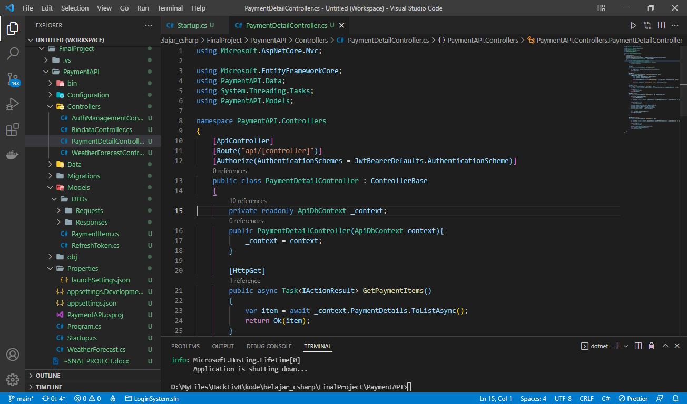

1. Setelah itu menjalankan pada terminal

* dotnet ef migrations add “Initial”
* dotnet ef database update

